AN-4001

Automatic and manual switching of backup power using the GLF74130

Leon Ren

Introduction

This application note describes designs that use GLF74130 automatic and manual switching mode. The automatic switching can be done without the help of GPIO (General Purpose Input Output) signals from an MCU (microprocessor). The manual switching mode requires control signals from an MCU and then switches the power rail according to the needs of the system.

Automatic and Manual Selection Mode

The auto mode example uses a 5 V USB as the main power supply and a 3.6 V Li-ion battery as the backup power supply. When the main power supply is connected, the main power supply supplies power to VOUT. When the main power supply voltage is lower than the battery voltage, the system needs to switch to the backup power supply without interrupting the normal operation of the system. If not switched, this may cause the downstream load to reset or enter an undervoltage lockout state. Lithium batteries are often used as a backup power source in order to ensure a minimum VOUT for the system.

Figure 1. Auto Selection Mode

The manual mode example uses 5 V and 3.6 V as the input power for both channels. With the EN and SEL mode configurations in Table 1, the GLF74130 selects either one of 5 V and 3.6 V to supply power to VOUT.

Figure 2. Manual Selection Mode

SEL | EN | Function | VOUT
0 | 0 | Both switches are off. | High-Z
0 | 1 | Auto-Input selection. VOUT is connected to a higher input source automatically. | Higher Input between VIN1 and VIN2
1 | 0 | Only VIN1 is selected. | VIN1
1 | 1 | Only VIN2 is selected. | VIN2

Table 1. Truth Table of Input Source Selection

Design Example – Auto Selection Mode

At the condition of EN=High and SEL=Low, the GLF74130 uses a comparator between the two outputs to determine the preferred power source. This mode can be easily implemented by pulling SEL down to ground and connecting EN to VIN2. Figure 3 shows the application circuit for this configuration.

Figure 3: Auto Mode Schematic

Parameters | Symbol | Value
Main Input Power | VIN1 | 5 V USB
Auxiliary Power | VIN2 | 3.6 V Lithium battery
Output Voltage | VOUT | Selected for higher voltage between VIN1 and VIN2
Output Capacitance | C_{OUT} | 100 µF
Load Resistance | R_{L} | 500 Ω

Table 2. Auto Mode Example Specifications

Plug-in 5V USB

Figure 4 shows the moment where the main power supply (VIN1) is connected under the condition that the backup power supply (VIN2) is being used, at which time the Vout is automatically switched to the main power supply.

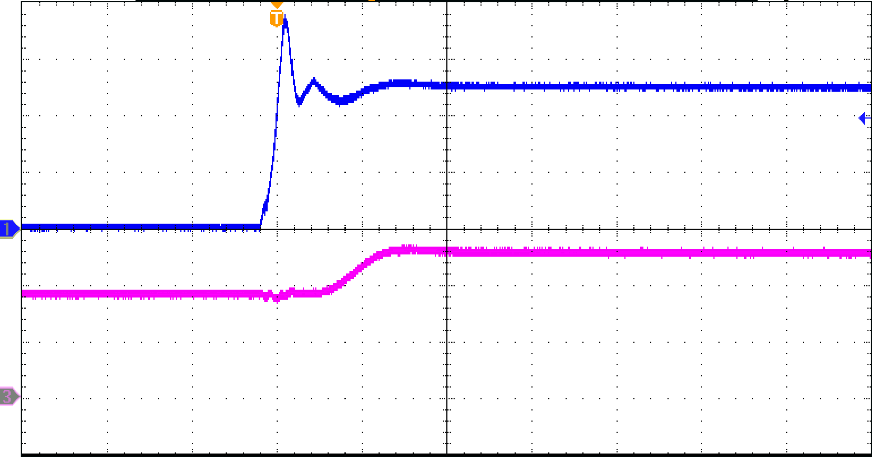
VIN1 [2 V/div]
VOUT [2 V/div]
40 us/div

Figure 4. Automatic mode switching from VIN2 to VIN1

Unplug 5V USB

Figure 5 shows the case where Vout is automatically switched to the auxiliary power supply after the main power supply (VIN1) is removed due to a fault under the condition that the main power supply (VIN2) is used.

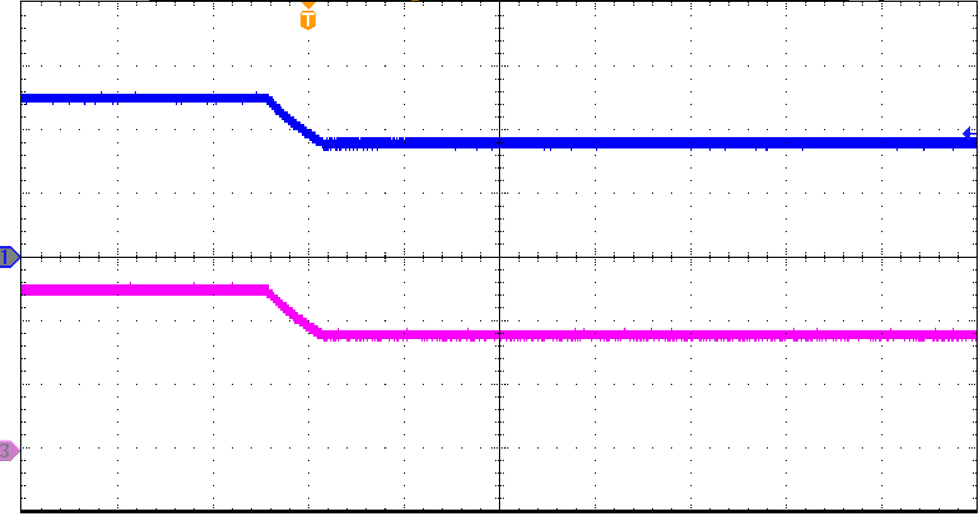
VIN1 [2 V/div]
VOUT [2 V/div]
20 ms/div

Figure 5. Automatic mode switching from VIN1 to VIN2

Design Example – Manual Selection Mode

When the SEL pin is at high state, the device enters a manual mode where different inputs are enabled by changing the level of EN pin. This mode can be easily realized by connecting SEL to VIN1 and EN to the MCU or other control elements. Figure 6 shows the application circuit for this configuration.

Figure 6: Manual Mode Schematic

Switching from 5 V USB to 3.6 V

Figure 7 shows how Vout is set from VIN1 to VIN2 by changing the EN logic level (Low to High) when Vout is set to VIN1.

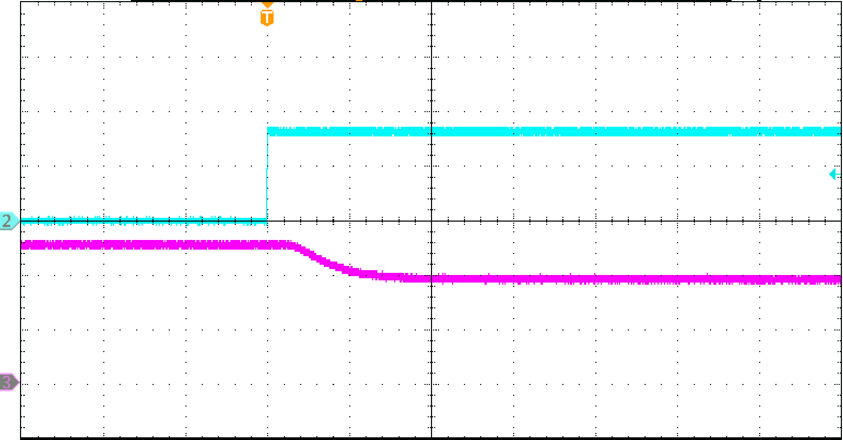
VOUT [2 V/div]
EN [2 V/div]
40 us/div

Figure 7: Manual mode switching from VIN1 to VIN2

Switching from 3.6 V to 5 V USB

Figure 8 shows how Vout is set from VIN2 to VIN1 by changing the EN logic level (Low to High) when Vout is set to VIN2 (3.6V).

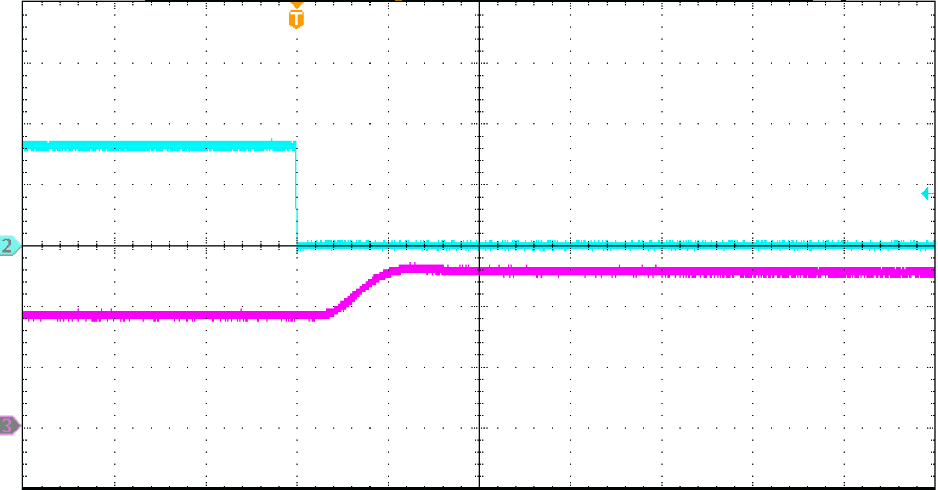
EN [2 V/div]
VOUT [2 V/div]
40 us/div

Figure 8: Manual mode switching from VIN2 to VIN1

Parameters | Symbol | Value
Main Input Power | VIN1 | 5 V USB
Auxiliary Power | VIN2 | 3.6 V Lithium battery
Output Voltage | VOUT | Depending on the EN, SEL logic level:  SEL=High, EN=Low, VOUT=VIN1.  SEL=High, EN=High, VOUT=VIN2.
Output Capacitance | C_{OUT} | 100 µF
Load Resistance | R_{L} | 500 Ω

Table 2. Manual Mode Example Specifications

Conclusions

This application note describes the Auto Mode and Manual Mode design of the GLF74130. The auto mode design allows the GLF74130 to be a standalone product reducing power consumption without any MCU engagement. While the manual mode design allows the system to freely switch input power sources. The GLF74130 supports both automatic and manual switching without interrupting normal operation.

